Team name: THE 4 MARVELs

Title of your project: You killed my master now you must die

Team members: John Rucker, Vu Tran and Seunghun Han

Description: Our project proposal will be a scene depicting a hero seeking vengeance against a tyrant who has killed his master/family. In the scene our hero walks down a path to battle 3 henchmen. Each henchmen fight will be short with each being more difficult than the one before with the evil boss looking on and laughing as the hero gets closer. After the hero defeats the henchmen the boss jumps in and the true battle begins

Blender models: Stick men figures with weapons (swords/bo staff/spear/ton fa)



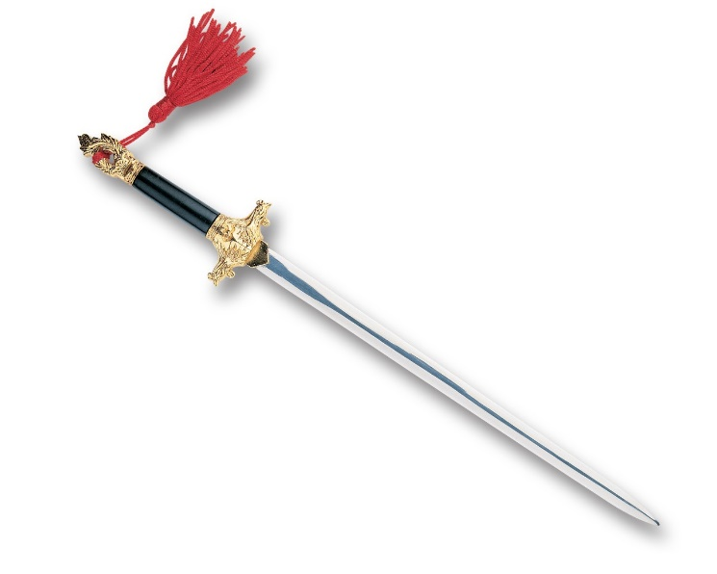

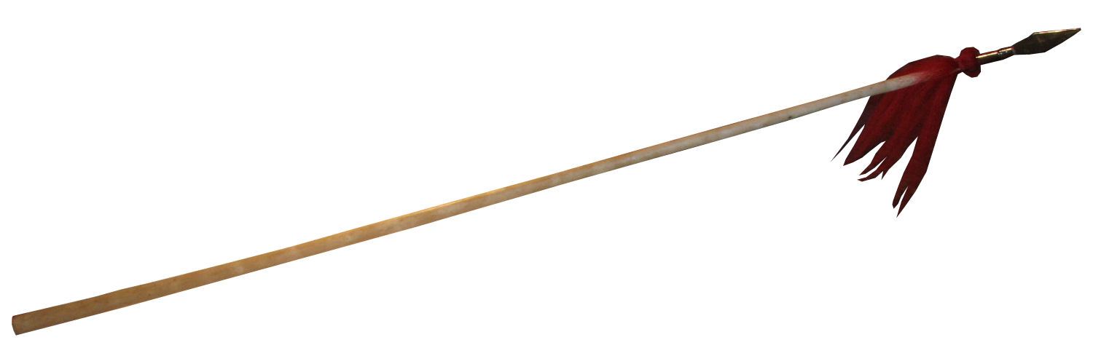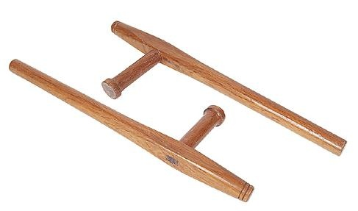

Environment: Chinese temple

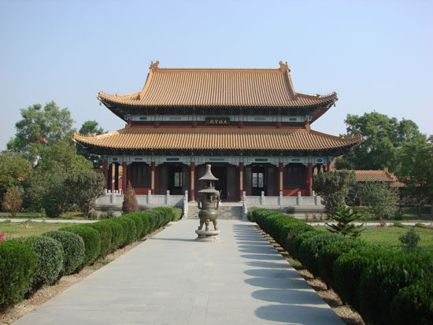

Scene will take place in a temple environment similar to the one with a temple in the background

Hero Color -



Green Villian 1 - 

Purple Villian 2 - 

Yellow Villain 3

Red Boss -

